Iteration 4

Wednesday, 11 March 2020

11:45 AM

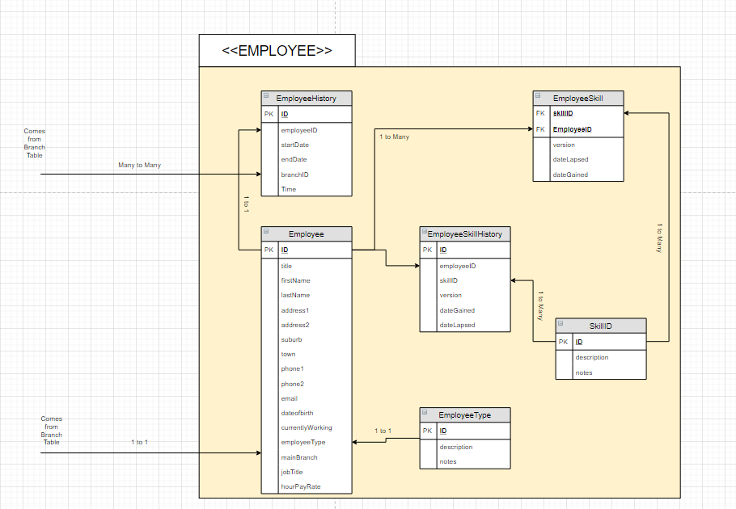

Multiplicity of **EMPLOYEE** grouping